Scaling

The training dataframe has all columns in the range of 0 and 1 except ‘tenure’ and ‘MonthlyCharges’, hence MinMaxScaling is applied to these columns to scale them in the range of 0-1.

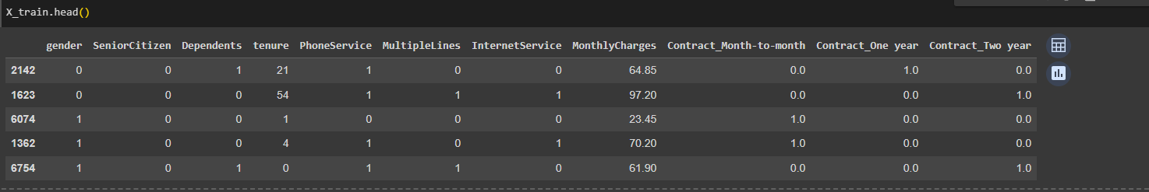

Figure : Training feature dataset

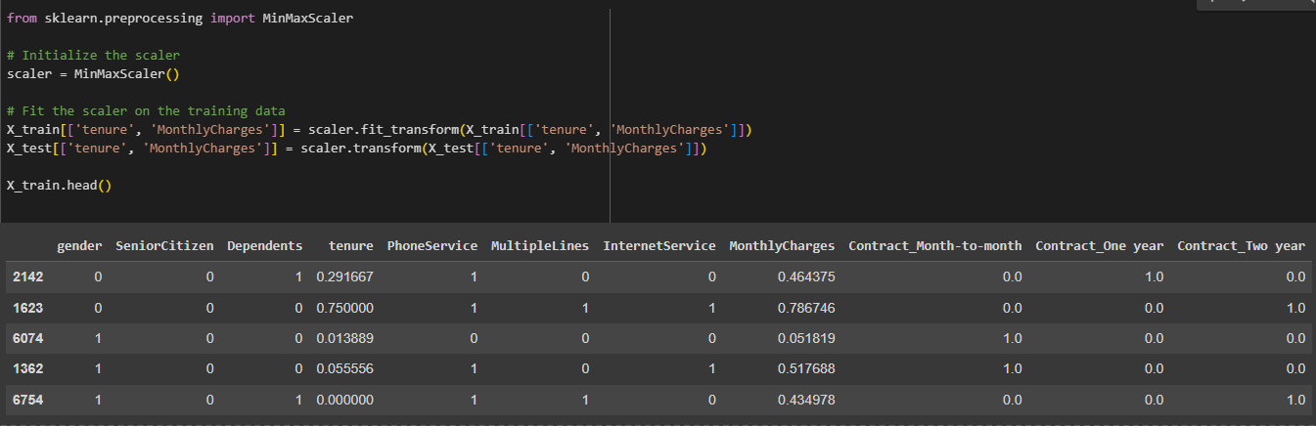

Figure : Dataset after scaling

Now, all the columns are in the range of 0-1 and can be used for making machine learning models for better accuracy and effective analysis of data.